**The Phantom of Spira**

**Self DM and DM Handbook**

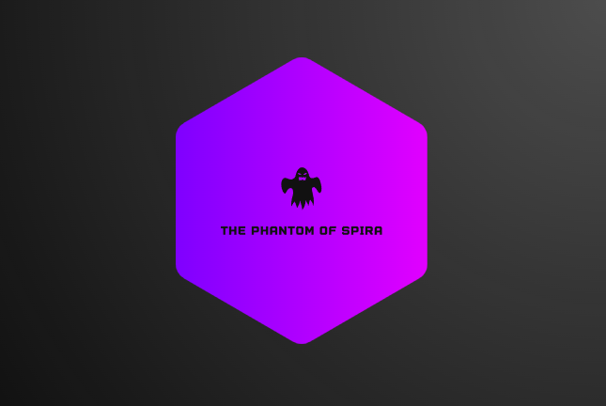

**Please note that this handbook is still under development and any information listed may not be official.**

**Welcome to the Phantom of Spira: A Text-Based MMORPG for open-minded gamers.**

**Table of Contents**

**Welcome to The Land of Spira** **3**

When the session starts. 3

**Rules as a Dungeon Master or Self DM 4**

As a Dungeon Master, you are responsible for keeping track of the following: 4

**Mob Encounters 5**

Battle 5

**Treasure Chest Loot 6**

Determining The Tier of a Chest 6

**Days of Travel 7**

Rolling for days of travel 7

**Dungeon Encounters 8**

How to start a dungeon and how to use the dungeon sheet. 8

**Questing 9**

How to start a quest. 9

**Shopping and Activities 10**

Shop and play. 10

**Link to Players Handbook:**  [TPOS Players Handbook](https://docs.google.com/document/d/1l4kT6hDRskf8K-mmCr6Wh02qvapqnanrfzJU0wcbdTU/edit)

# **Welcome to The Land of Spira**

## **When the session starts.**

When the session starts make sure each player has pulled up their Character Sheet, The World Map, the Town/Area Directory, and The Mob Finder **(Optional for players who want to see mob encounters) (The mob finder can be found in the Enemies folder)**

Make sure you as the DM have the Mob Finder, Mob Viewers **(For multiple enemies of different types).** ChestGen, World Map, and Town/Area Directory Pulled up.Once everyone has everything pulled up you or the party can decide what they want to do.

# 

# 

# 

# 

# 

# **Rules as a Dungeon Master or Self DM**

## **As a Dungeon/Game Master, you are responsible for keeping track of the following:**

* Mob Encounters
* Days of Travel
* Treasure Chests
* Dungeon Encounters
* Keeping Track of Stats of Mobs
* Guiding quests for the party.
* Allowing people to freely shop and do activities inside of a Town/Area if they choose to.
* More that may not be specified just yet.

# 

# **Mob Encounters**

## 

## **Battle**

The dm or quest determines when the players encounter a mob/enemy, when the party encounters an enemy the dm may choose to allow the party to talk to the creature or the dm can choose to have the creature engage the party in battle instantly. ***(please see battle rules in the player handbook for more info revolving around what you can and cannot do before a battle engages)*** When the battle begins the dm rolls a dX X= 2 times The number of players in the battle. The players then roll a d20 for their turn order and the dm rolls a d20 for the enemy's turn order and everyone adds any bonuses they may have to their rolls. The highest total number goes first to last in the turn order. The dm may choose to roll for each enemy individually or all at once.  
  
During the mob's turn, the DM gets to choose what actions the mob makes whether they use a power/spell, a piece of equipment they have equipped, or if they want the enemy to try and flee the battle. You can also choose to pass your turn.  
  
When a player or mob rolls to flee add the player or mobs mobility bonuses to their roll.

# 

# 

# 

# 

# **Treasure Chest Loot**

## **Determining The Tier of a Chest**

The dm can choose whether or not the party encounters a chest during a good day of travel. The recommended roll for a good day of travel to encounter chests is a 90 or higher on a d100.

To determine the tier of a chest, open up the ChestGen sheet in the Enemies Folder and have either you or a random player roll a d10 to determine the tier. Once the tier is determined by a roll, input the data into the ChestGen and click on the check box next to the tier number. You may keep regening the loot until you see items that seem fit.

# 

# 

# 

# **Days of Travel**

## **How to Travel**

When the party is ready to travel along the map **(not inside of a town/area)** Pull up the MobEncounters sheet within the enemies folder and input the amount of days the party is traveling into the days of travel box. A 50 or lower is considered a bad day of travel **(mob encounter)** a 51 or higher is considered a good day **(Treasure Chest, Ask if a party member wants to search for Herbs, etc.)**

# 

# 

# 

# 

# **Dungeon Encounters**

## 

## 

## **How to start a dungeon and how to use the dungeon sheet.**

At the start of a TPOS session or during the session, you can ask the party if they want to participate in a dungeon for the current game session. If not then continue with a normal session. If the party agrees to partake in a dungeon, pull up the DungeonViewer sheet in the Enemies folder. Once pulled up, select the dungeon the players want to partake in and set the floor to room 1 floor 1 and go up from there. A dungeon acts as multiple stages of battles with a standard set amount of enemies.

## 

## 

## 

# 

# **Questing**

## **How to start a quest.**

During a session of TPOS when you and the party enter a Town/Area there will be a Quest Board in most towns/areas. Pull up the Quest Board Sheet and you should see quests marked as **(Side aka Side Quest)** if the town does not have a Side Quest go to another town/area. When starting a quest read over the quest yourself in your head before starting it, do not let the players read the quest you are starting for the party. Follow the quest directions and guide the party on their way. Feel free to reword the quest in your own words while telling the questline so it doesn't spoil certain things in the quest for the party.

# 

# 

# 

# 

# 

# **Shopping and Activities**

## Shop and Play.

When exploring towns and areas within the Land of Spira people can buy items, spells, equipment, and town services from the Town/Area they are in. Make sure the player that is buying an item inputs the proper amount of gilders into the Shop money section before taking the item from the shop or it is considered stealing. Make sure the player that purchases a town service inputs the money into the town bank vault, Make sure the player also inputs the amount of items they bought into each sold box.

Some towns and areas offer minigames or fishing. You may ask the party if they'd like to partake in a mini-game or if they want to fish while they are in a Town/Area that offers it.